**Assessment 3**

1. **Unit Testing**

In unit testing, units of codes are tested to verify that these units work according to the expectation. Through unit testing, we can check that certain part of the code or class are working appropriately or not. In our unit testing, we are checking the different codes that are required to implement for the use case “Borrow a Book.” We will check that every unit of the software is working according to the design. So, unit testing helps to change and maintain the code.

We performed unit testing for two modules that are “BookDAO.java” and “Member.java”. The first module “BookDAO.java” retrieve the information of the book that includes the book title, Author name, Book number, etc. The second file “Member.java” help the system to retrieve the information about the user that include member name, member Id and to check that he/she is eligible for borrowing the book or not.

**Class memberTest.java code -**

package library.test.memberObjects;

import static org.junit.Assert.*;

import org.junit.Test;

import library.entities.Member;

public class MemberTest {

           @Test

           public void test() {

                       Member me=new Member("FName1","IName1","002","email1");

                       boolean test=me.hasOverDueLoans();

           assertTrue("The testing for the method hasOverDueLoans() was not successfull", test);

           }

}

I used the above code to perform the unit testing on the modules. For this, I used JUnit class of Java that provides the function Assert for testing the modules. It becomes easy to test the modules using Assert function.

The result of above code is:

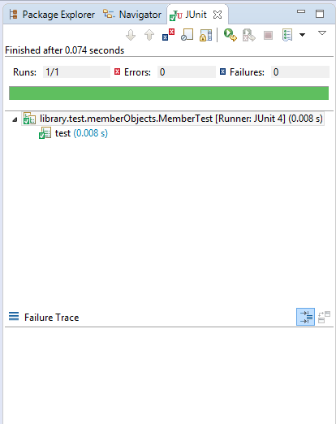

**Execution window of Class memberTest.java**

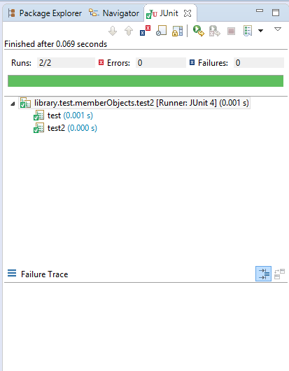

**Execution window of Class memberTest2.java**

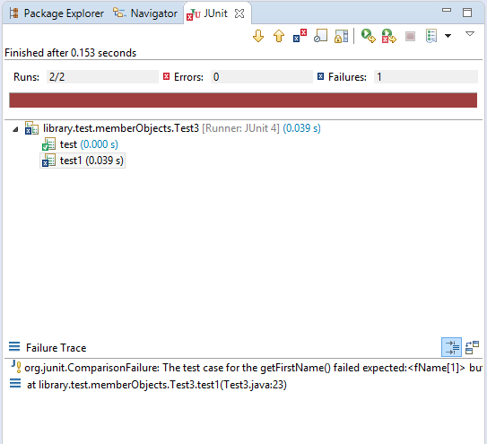

**Execution window of Class memberTest3.java**

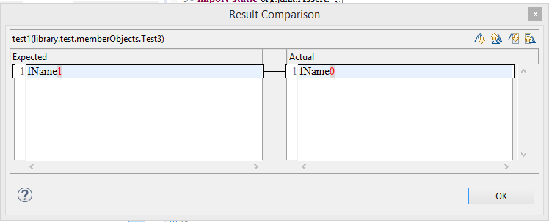

**Result Comparison of Class test3.java**

Similarly, I performed other tests using the BookDAO.java and Member.java classes that I created.

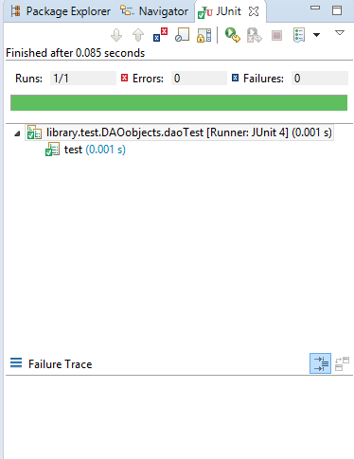

**Execution window of Class daoTest.java**

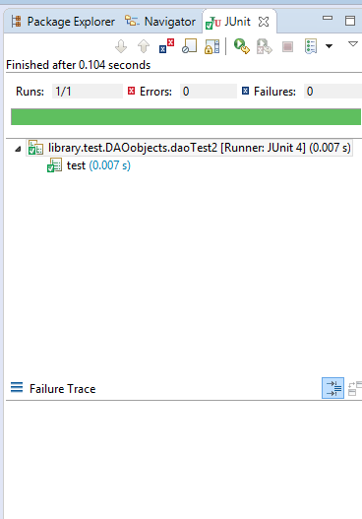

**Execution window of Class daoTest2.java**

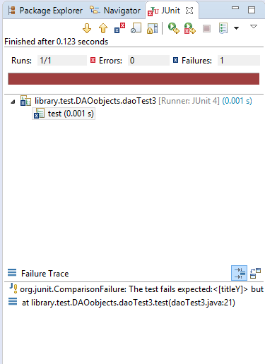

**Execution window of Class daoTest3.java**

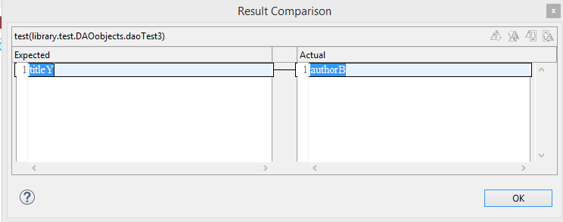

**Result Comparison of Class test3.java**